Kwong Yuet Michael Fadillah Wong

There are total of 5 biases, and 25 weights (including bias weight).

The final biases are [0.0077 0.2256 0.6388 0.0638 0.3908]

The final weights are

0.2610 7.3676 -5.5782 -4.4943 -4.4640

-10.1258 3.9726 3.9686 1.8323 -2.2955

-0.8771 8.1950 -2.7106 -1.2992 -1.5605

-11.0599 -5.4021 7.8043 3.6680 -0.8904

-9.5341 -7.1123 14.1634 -9.0533 -15.3739

Below is the SSE plot

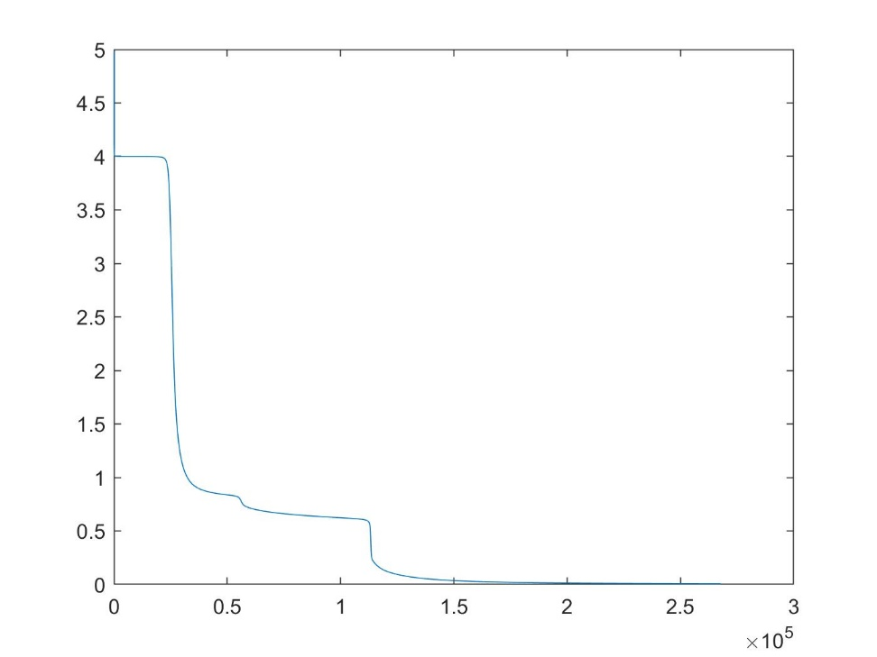

Extra credit:

Here is the number of run time by incrementing learning rate by 0.05

Learning rate : 0.05 0.1 0.15 0.2 0.25 0.3 0.35 0.4 0.45 0.5

Number of iteration: 35725 17039 10384 8344 6283 5819 7028 3028 2472 1513

The number of iterations greatly decreases in the beginning, then decreases slowly at the end.

Below is the visualization

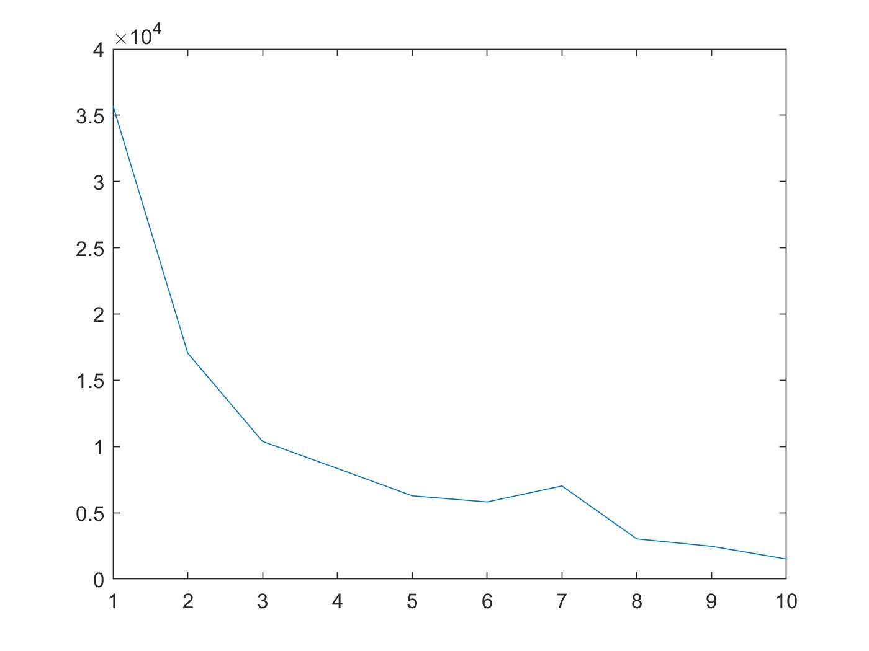

By adding alpha = 0.9, the number of iteration greatly decrease. However, error between ideal output and actual output significantly increases.